FOOD ORDERING SYSTEM [FOS]

USECASE DIAGRAM :-

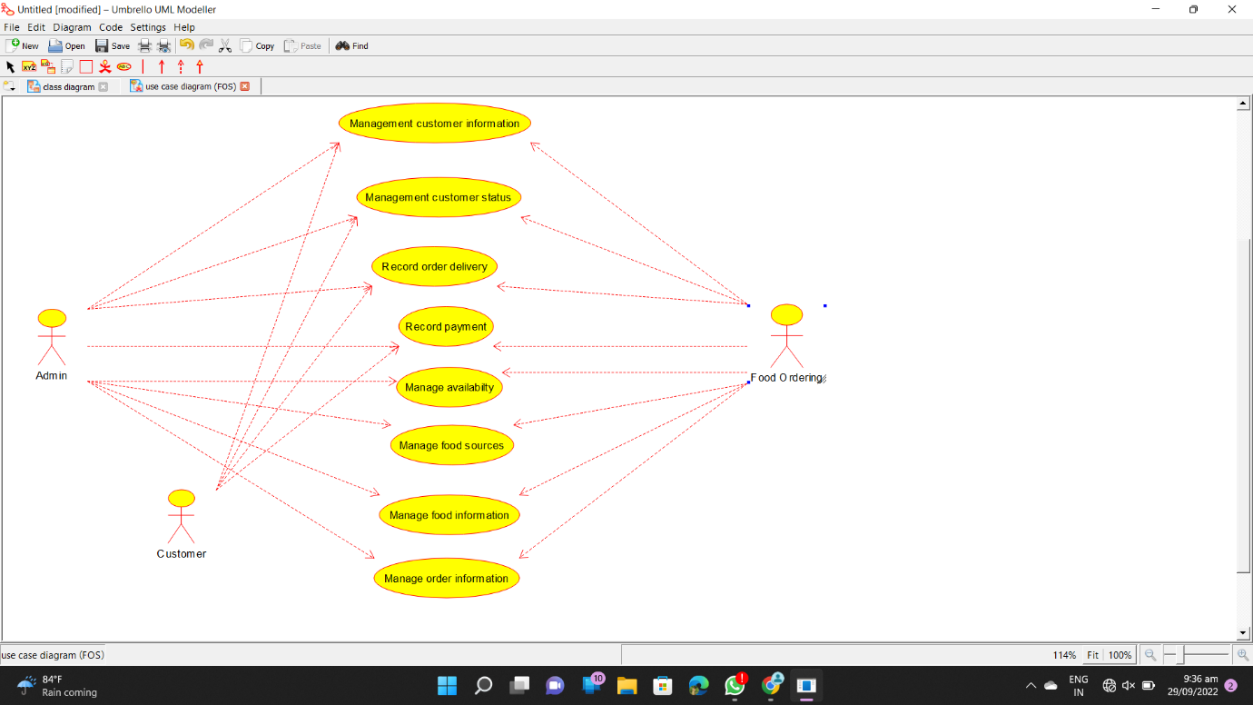

CLASS DIAGRAM :-

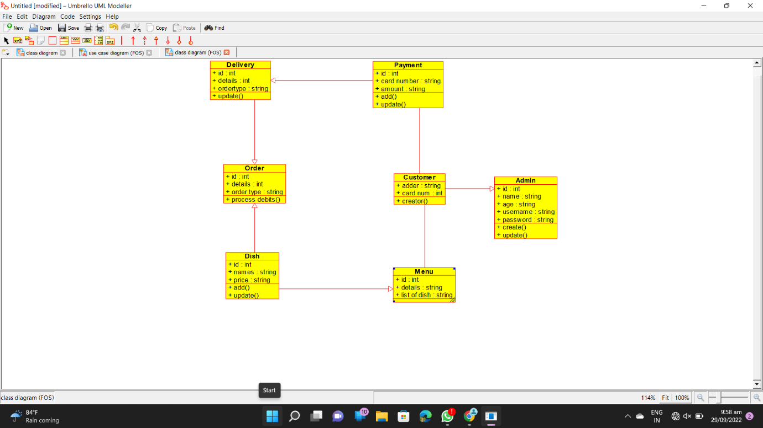

ACTIVITY DIAGRAM :- 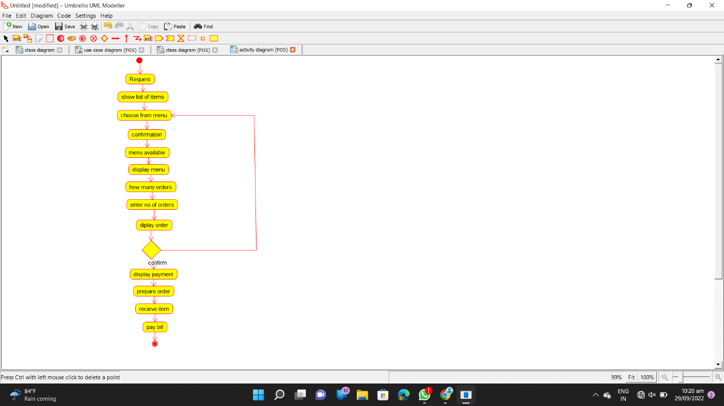

SEQUENCE DIAGRAM :-

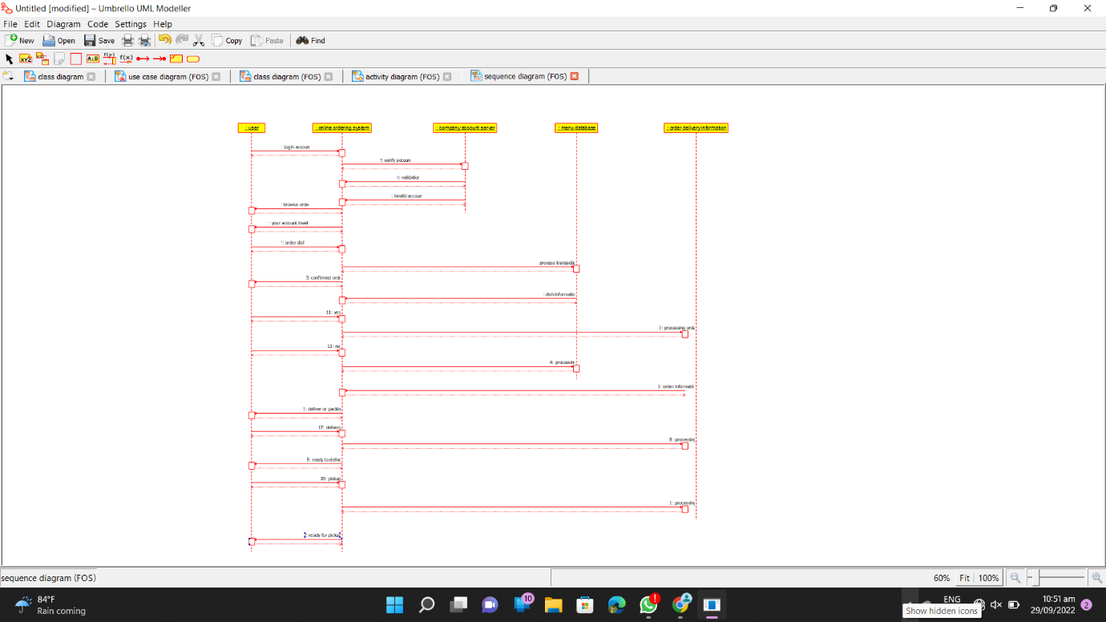

COLLABORATION DIAGRAM :- 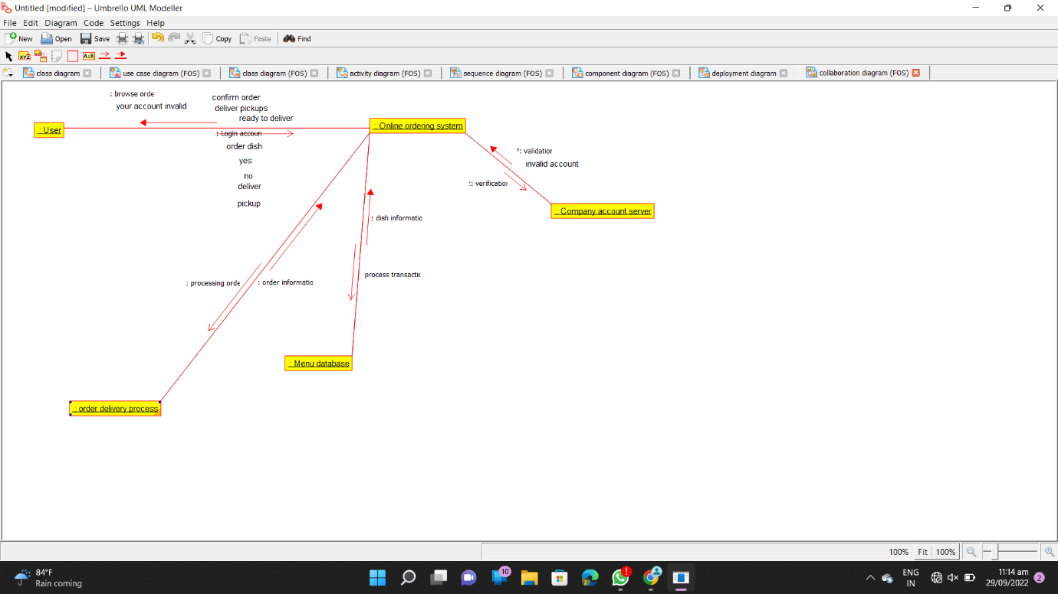

COMPONENT DIAGRAM :-

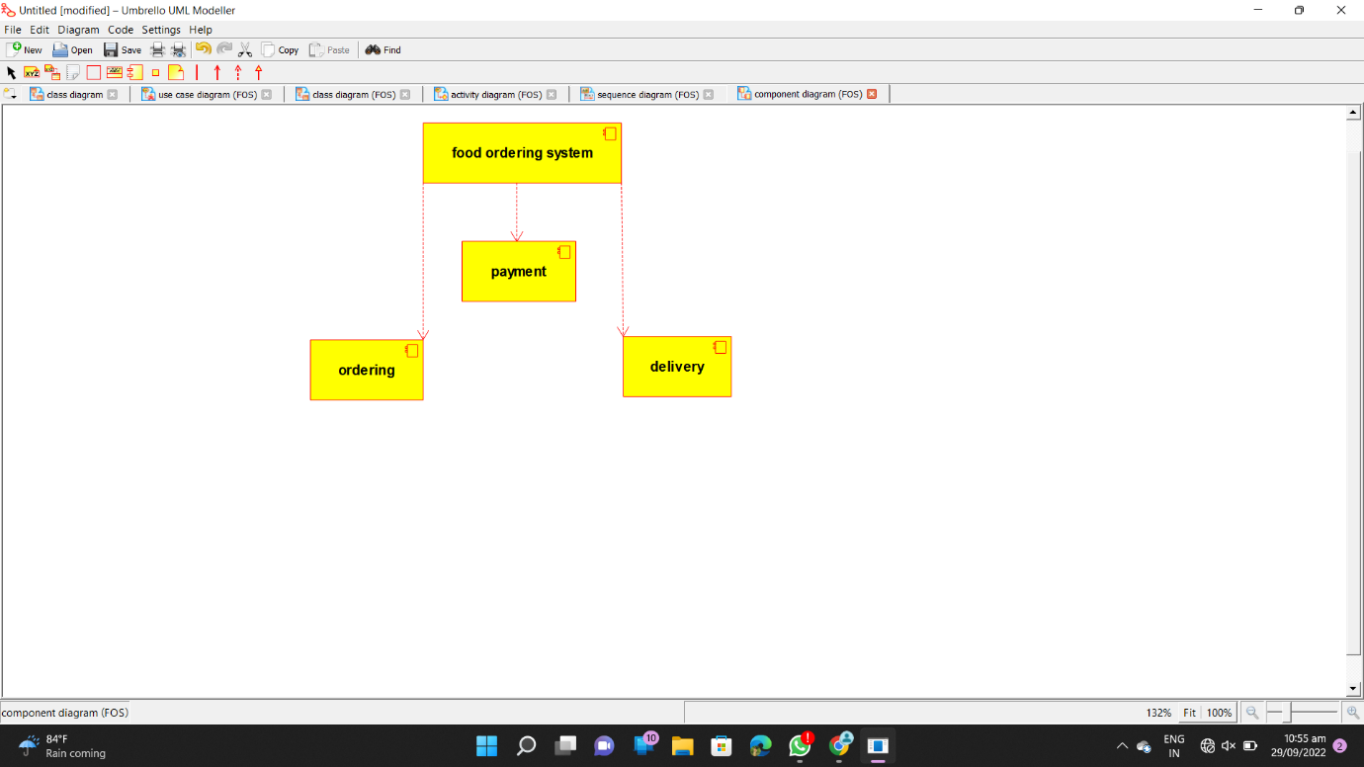

DEPLOYMENT DIAGRAM :- 